**Home Work 2 – Excel VBA**

**PLEASE READ THE FOLLOWING IMPORTANT NOTES:**

1. I have done the “Hard” part of the Homework.
2. I have hard-coded some output columns; therefore, the data in the Excel file where you test my code should be in Columns A through G in all 3 Worksheets (2016, 2015 and 2014).
3. My code writes the results in Columns I through S. The code (at this time) does not have the ability to erase the previously written results and over-write them if it is run again. I am working on making this change (as a personal challenge) but I don’t think I can do it by the due date. I made a few attempts but it did not work like I wanted it to. **THEREFORE**, if you want to test it multiple times, you need to delete the contents of Columns I through S in each Worksheet and re-run each time.
4. I have added columns “Opening Price” and “Closing Price” in addition to the columns required per the instructions. I hope this is OK.

My Outputs are given in the following pages.

Following output is for year “2016”.

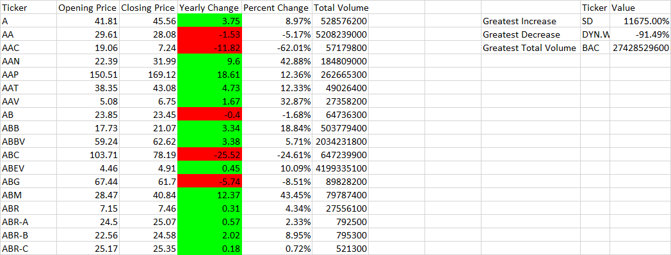

Following output is for year “2015”.

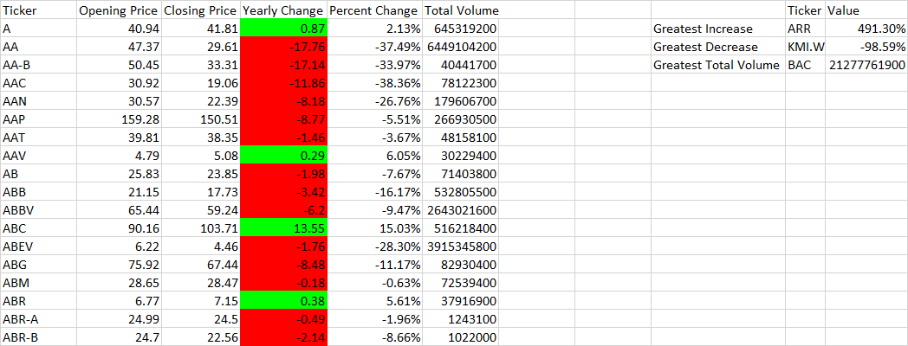

Following output is for year “2014”.

